Consulting Resume: The One-Page Format That Passes the Screen
Meta description: WSG founder Stephen Turban shows the one-page consulting resume format MBB screeners pass, with two full sample resumes and the bullet rewrites that work.

The night before Bain's first Associate Consultant Intern deadline last spring, a sophomore I work with through WSG, call her Ana, emailed me two attachments and a one-word subject line: "Which?" One file was her consulting resume. The other was her banking resume. The banking version led with a boutique investment banking internship and bullets about comps and a pitch book, and it squeezed the two years she'd spent running a 60-person nonprofit chapter into three lines near the bottom. The consulting version turned out to be the same page with the sections swapped and the word "Leadership" added to a heading.

I'm Stephen Turban, founder of WSG. I went through McKinsey's recruiting myself and now read consulting resumes from undergrads most weeks, and Ana's problem is the one I see most often: students treat a consulting resume as a banking resume with the order changed. The screener is scoring different things, in a different order, and the page has to be built for that read. We rebuilt hers that night using the format below. She submitted before midnight, got the first-round interview, and had her Bain offer by the end of spring.

This article covers how the MBB screen actually scores a page, the one-page skeleton with its consulting tilt, two full sample resumes (a junior with a consulting internship and a sophomore with none), and the bullet rewrites that turn a list of duties into evidence. Our consulting resume checklist covers the line-by-line rules with example bullets; this is the format itself, with two full pages to model.

What do consulting firms look for on a resume?
Consulting firms screen a resume for four things, roughly in this order: academic strength, leadership, measurable impact, and something distinctive enough to remember. Academic strength means GPA, school, the rigor of your major and sometimes test scores. Leadership means you ran something with people in it, and impact means the thing you ran changed by a number you can defend. McKinsey's own careers pages describe the people it wants as "distinctive, driven, curious," and BCG's careers FAQ says it looks for "ethical, results-driven, curious, and excellent problem solvers" who can work on a team. The resume is where you prove each of those words with a line someone can check.

Should a consulting resume be one page?
Yes. One page, and the firms will cut a two-page undergrad resume before anyone reads the second page. Screeners at McKinsey, BCG and Bain read in stacks, and a consultant's first job is deciding what matters in a pile of information, so a resume that can't make that cut suggests you can't either. One page means 10 to 11 point font, half-inch to three-quarter-inch margins, and no tricks with the line spacing. If you're over, cut your weakest bullet, not your margins.

How the MBB resume screen scores a consulting resume
Start on the firm's side of the table. McKinsey receives about 1 million resumes a year and told Business Insider it planned to hire about 1 percent of applicants [VERIFY: Business Insider report via Yahoo Finance, January 10, 2026; McKinsey's current figures]. BCG and Bain don't publish their numbers, but they recruit from the same schools for classes of similar size, so their math looks similar. No firm can interview even a tenth of that pool. The resume screen exists to get the stack down to the people worth 45 minutes of a consultant's time, and everything about how it works follows from that.

It also matters who's reading. At the schools a firm recruits from directly, the first read is usually done by consultants who went to your school, with a recruiter coordinating, and they get a stack and a few hours. At schools the firm doesn't visit, your application lands in a general pool that recruiting staff read first. Either way the reader is working fast and has read many pages that look like yours.

The first read of your resume takes seconds, and the top third of the page decides whether there's a second read. The clearest evidence on how people read resumes comes from an eye-tracking study by the job site Ladders. In its 2018 study, recruiters spent an average of 7.4 seconds on the initial look at a resume, up from 6 seconds in its 2012 study. They spent more time on job titles than on anything else. Simple layouts with clear section headings scored best, and cluttered pages with long sentences, multiple columns and little white space scored worst. A consulting screen is more careful than a job-board scan, but the shape is the same: a fast first pass sorts you into "read properly" or "no," and only then does someone read your bullets. Your school, GPA, major and first job title are what the fast pass sees.

Here is what the slower read scores, in the order it tends to happen. The firms don't publish a scoring sheet, so this is the pattern I've seen across the students I've worked with and across what the firms say publicly about who they hire.

1. Academics come first because they're the cheapest signal that you'll survive the case interview and the analytical work. GPA, school, major rigor and sometimes test scores can be checked in two seconds. In my experience the effective bar at MBB for students at the schools they recruit from sits around a 3.7, with real exceptions for a strong story, and it sits higher for students applying from the general pool [VERIFY: founder's current read on the effective MBB GPA bar]. That's a pattern, not a published cutoff.

2. Leadership comes second because the job puts you in charge of people who don't report to you. By your second year as a consultant you're running a workstream (one piece of the project, with its own analyses and its own deadline) alongside client staff who have their own bosses. The firm wants evidence you've organized people before, so the screener looks for titles, team sizes, and whether you chose the role or were handed it.

3. Impact comes third because consulting is measured in whether the client's number moved. "Managed the marketing committee" says you were present. "Grew membership from 40 to 110 in one semester" says something changed because you were there. The screener is looking for the second kind of line, and for enough of them to believe it's a habit.

4. Something distinctive comes last, and it's what gets you remembered after the sixtieth resume. A business you started, a national ranking in anything, a second language you actually speak, an unusual path to college. One line is enough. Without it, a technically perfect page blends into the stack.

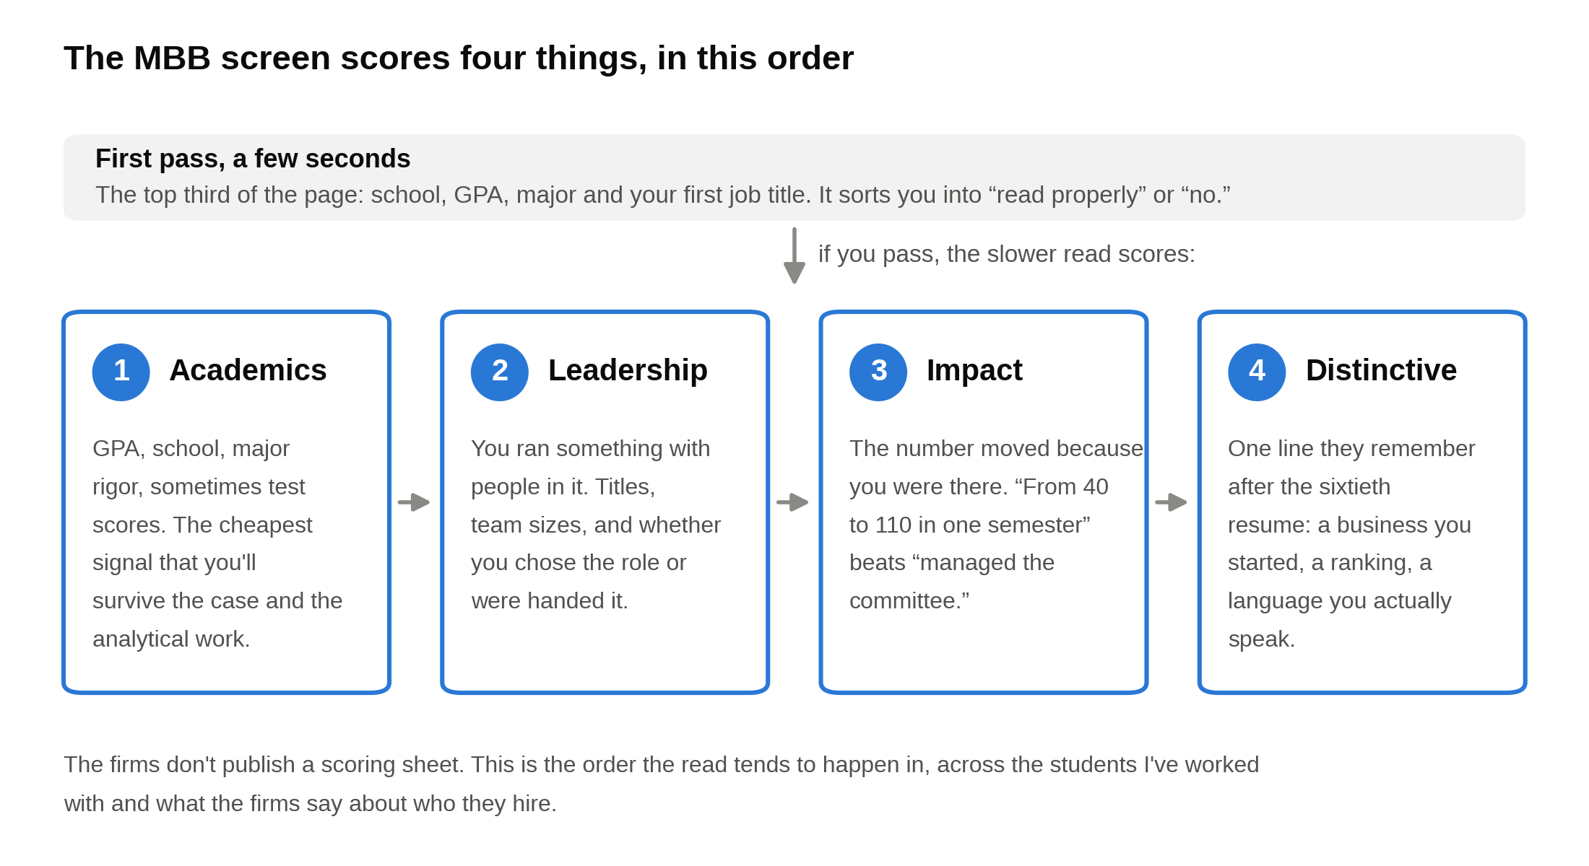
Academics get read first and the distinctive line last, so the top third of your page has to carry the first two scores on its own.

One change in that order is worth knowing. In a January 2026 interview, McKinsey's global managing partner, Bob Sternfels, said the firm had gone back through two decades of its hiring data and found that applicants who had a setback and recovered from it were more likely to go on to make partner. He said the firm's screens had carried "some bias" toward "perfect marks." For your page, that means a line showing a rebuild (a club you took over at 15 members, a venture that failed and what you built next) is a plus, not something to hide behind a vaguer bullet.

Timing matters because the screen happens on the firm's calendar, not yours. For a sophomore reading this in October 2026, the applications that count come in 2027, for Summer 2028 internships. In the last cycle, McKinsey's Business Analyst Intern window ran January 1 to March 29, 2026, for students graduating December 2027 to August 2028 [VERIFY: McKinsey's US undergraduate page for the Summer 2028 window]; BCG's Summer Associate deadline was June 2, 2026, with no fall round [VERIFY: BCG's US Associate page for the Summer 2028 deadline]; and Bain's Associate Consultant Intern application had two windows, March 29 and August 31, 2026 [VERIFY: Bain's ACI page for the Summer 2028 windows]. If the firms hold their pattern, McKinsey's window opens around New Year 2027, BCG's deadline lands in late spring or early summer 2027, and Bain's first window closes in spring 2027 [VERIFY: each firm's posted Summer 2028 dates]. Our consulting recruiting timeline tracks the dates as they post. Finish the consulting resume by December of sophomore year, because the MBB windows for Summer 2028 internships are expected to open in early 2027. Juniors in the Class of 2028 are on a different clock: tier 2 and Big 4 strategy internships for Summer 2027 run rolling through this fall, and MBB full-time applications come next summer.

The consulting resume skeleton: five sections, one page, nothing else
The skeleton is the same one in our investment banking resume template, because both screens reward the same thing: a page a tired reader can process in order. Five sections, top to bottom:

- A header line: your name in capitals, then phone, email, city and LinkedIn on one line. No street address, no photo, no title under your name.
- Education: school, city, degree and major, expected graduation month and year. A GPA line with test scores if you're listing them. A coursework line only if it adds quantitative signal.
- Experience: paid or formal roles, most recent first. Two to three bullets each.
- Leadership & Activities: clubs, elected roles, competitions, teams. Two to three bullets for your biggest role, one or two for the rest.
- Additional Information: technical skills you've actually used, languages with honest proficiency, and two to five specific interests.

That order isn't arbitrary. Education sits first because academics score first. Experience sits second because the fast pass looks for a job title. Leadership sits third but gets real room, which is where the consulting version starts to differ from the banking one.

The consulting tilt changes five things on the same skeleton:

- Leadership gets more room. On a banking page, Leadership & Activities is often two short entries at the bottom. On a consulting page, three entries with two to three bullets each is normal, and for a sophomore it can be the longest section.
- Every bullet ends in a result with a number. A banking bullet can lead with deal size ("a $2.1Bn acquisition") because the deal itself is the credential. Consulting has no deal to borrow credibility from, so the number has to be the outcome you produced.
- Breadth matters. The screener wants to see you do more than one kind of thing well: an analytical job, a role where you led people, and something outside both. A page that's all finance, or all student government, reads narrow.
- Test scores sometimes appear for underclassmen. As a rule of thumb, if your SAT is 1500 or above or your ACT is 34 or above, it can sit on the GPA line as a sophomore or junior. BCG's US application has a field for SAT or ACT scores and tells you to leave it blank if you don't have them [VERIFY: current BCG US application form], so the firm may see the number whether or not it's on your page.
- Languages and international experience earn a line. The three firms staff projects across offices, and a real second language can get you put on work in that language. List it with honest proficiency (fluent, conversational, basic), because interviewers who speak it will test it.

A short piece of history makes the ordering point better than I can. The earliest known resume is a letter Leonardo da Vinci wrote in 1482, at age 30, to Ludovico Sforza, the ruler of Milan. It leads with portable bridges, siege engines and ways to drain a moat, because that's what Sforza was hiring for, and it mentions painting near the end, almost as an aside. He got the job and stayed in Milan nearly twenty years. The letter sits today in the Codex Atlanticus at the Biblioteca Ambrosiana in Milan. Order the page by what the firm is hiring for, not by what you're proudest of.

Formatting rules, so there's no guessing: one page, 10 to 11 point font in Arial, Calibri, Garamond or Times, 0.5 to 0.75 inch margins, black text, no color, no icons, no photo, no objective statement, no "references available upon request," no two-column layout. Dates written one way throughout ("Jun 2026 to Aug 2026"). Save as a PDF named with your first and last name and the word resume, so the recruiter can find it in a folder of 200 files.

Sample A: a junior with a consulting internship
Alex is a junior at a large public university, an economics major with a statistics minor, who interned at a tier 2 strategy firm in Summer 2026 after a freshman summer at a startup, and who runs the campus consulting club. The firm and company names are placeholders in the same style as our IB template; everything else is what the page should look like. Both samples are available as one-page PDFs, and the blank skeleton as an editable Word file [VERIFY: add the download links for "Sample Consulting Resume - Junior (Alex Doe).pdf", "Sample Consulting Resume - Sophomore (Sam Doe).pdf" and "WSG One-Page Resume Template.docx" once uploaded to Wix]. Here it is, top to bottom.

ALEX DOE
(555) 555-0147 | alex.doe@email.com | Madison, WI | linkedin.com/in/alex-doe-sample

EDUCATION

State University, Madison, WI. Bachelor of Arts in Economics, Minor in Statistics, Expected May 2028

- GPA: 3.82 / 4.00 | Dean's List, all four semesters | ACT: 35 | Honors Program in Economics
- Relevant Coursework: Econometrics, Intermediate Microeconomics, Game Theory, Data Analysis in R, Managerial Accounting

EXPERIENCE

Tier 2 Strategy Consulting Firm, Chicago, IL. Summer Consultant (Received Return Offer), Jun 2026 to Aug 2026

- Sized the US market for a healthcare client's at-home diagnostic test at $1.4Bn by building a bottom-up model from eligible patient counts, testing frequency and price; the estimate became the base case in the final steering committee presentation
- Analyzed 1,200 customer survey responses in Excel and R to segment buyers for a consumer products client; identified a 20% price-insensitive segment that the client built a premium product line around in its 2027 plan
- Ran 14 interviews with former distributors and category buyers and wrote the one-page synthesis the partner used to open the week-four client meeting; two of the findings became workstreams for the rest of the project

Early Stage Software Startup, Madison, WI. Operations and Strategy Intern, Jun 2025 to Aug 2025

- Rebuilt the customer onboarding checklist and cut average time from signed contract to first use from 9 days to 4 across 60 new accounts over the summer
- Built the company's first churn dashboard from billing data; showed that 40% of cancellations came from one pricing tier, which the founders repriced in September

LEADERSHIP & ACTIVITIES

Undergraduate Consulting Club, State University, Madison, WI. President | Previous Roles: Project Lead, Analyst, Sep 2024 to Present

- Lead a 70-member club that runs 6 pro bono projects a semester for local businesses and nonprofits; grew the member application pool from 90 to 210 in two years by partnering with the business school's career office and recruiting 4 new client partners
- Built an 8-week case practice program that pairs 30 members with alumni coaches each fall; 12 members received consulting internship offers in the 2026 cycle, up from 4 two years earlier
- Led a 5-person team for a regional food bank; redesigned its volunteer scheduling and raised shift fill rates from 70% to 92%, which the executive director reported saved about 15 staff hours a week

National Undergraduate Case Competition, Chicago, IL. Team Captain, Nov 2025

- Led a 4-person team to 2nd place out of 32 teams with a market entry recommendation for a regional grocery chain; built the 5-year financial model and presented to a panel of partners from two strategy firms

Club Rowing Team, State University, Madison, WI. Treasurer and Varsity Eight Rower, Sep 2024 to Present

- Keep the team's books: a $22,000 annual budget, a renegotiated boathouse lease that cut facility costs 15%, and a $6,000 alumni drive that paid for a new shell
- Row in the varsity eight, which placed 3rd at the Spring 2025 regional championship on 15 training hours a week

ADDITIONAL INFORMATION

- Technical Skills: Excel, PowerPoint, R, SQL, Tableau
- Languages: Fluent Spanish (summer language program in Madrid, 2024); conversational Portuguese
- Interests: Trail running, crossword construction, Spanish-language film, pickup basketball, woodworking

That's the whole page. Eleven bullets across Experience and Leadership, two lines of Education, three lines of Additional Information.

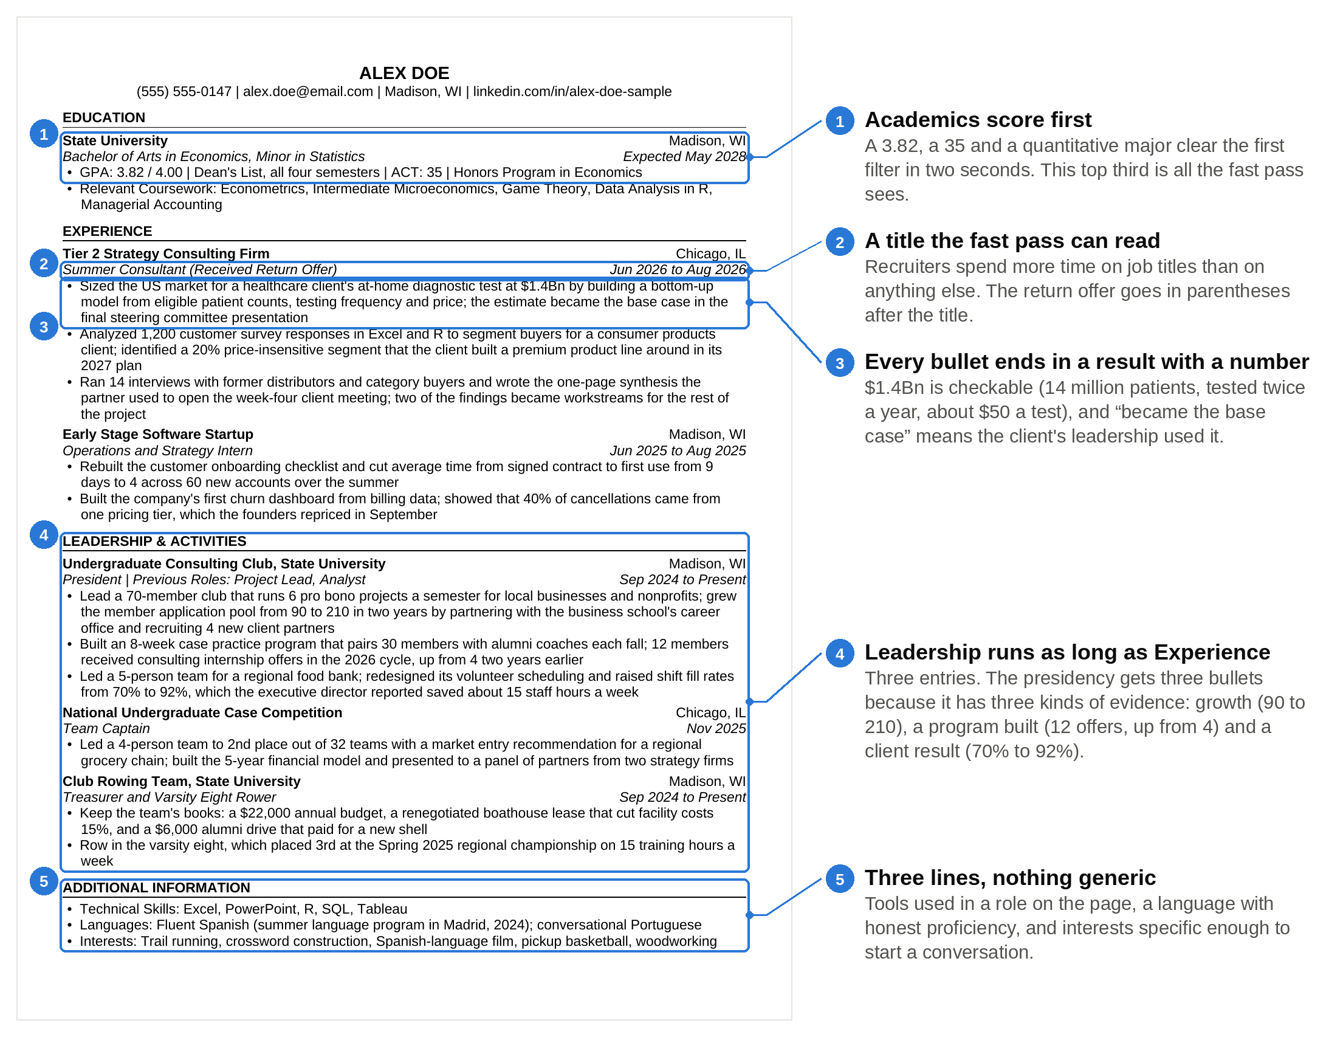
Run the screen on Alex's page: the fast pass sees a 3.82 and a strategy firm title, and the slower read finds a number at the end of every bullet.

Why does it pass? Run the screen on it. The top third gives the fast pass everything it wants in order: a 3.82, a 35, a quantitative major, then a strategy firm name and a title with "Received Return Offer" in parentheses. The slower read then finds a number at the end of every bullet, and every number is an outcome rather than a description of size.

Every bullet on a consulting resume has to survive five minutes of "walk me through this," because the interviewer will pick one and ask. Take the first one. "Sized the US market at $1.4Bn" is checkable: 14 million eligible patients, tested twice a year, at about $50 a test, gives $1.4 billion. The steering committee it mentions is the group of client executives who sign off on where the project goes, so "became the base case" means the client's leadership used the intern's number. If Alex can say that out loud and explain where each input came from, the bullet is an asset. If not, it's a liability, and the same test applies to every line you write.

The leadership section on a consulting resume is as long as the experience section, and that's correct. Alex's three leadership entries take up as much room as the two internships. The club presidency carries three bullets because it has three different kinds of evidence: growth (90 to 210 applicants), a program built from nothing (12 offers, up from 4), and a client result (70 to 92 percent fill rate). The distinctive line is the training program, because a screener remembers "built the thing that got 12 people hired" after the other 59 pages blur together.

Notice what isn't on the page. No objective. No "proficient in Microsoft Office." Nothing from high school. Rowing earns two lines because it carries a budget, a negotiation and a result; a sport with none of those would get one.

Sample B: a sophomore with no consulting experience who still passes
Sam is a sophomore, an applied math major with an economics minor, with no consulting internship and no finance internship. What Sam has: a part-time research job that started last summer, three summers working full-time in a family landscaping business, an elected finance role in the residence hall association, an analyst seat in the consulting club, and a first-place freshman case competition. This is the resume that gets a first-round interview for Summer 2028.

SAM DOE
(555) 555-0188 | sam.doe@email.com | Tempe, AZ | linkedin.com/in/sam-doe-sample

EDUCATION

State University, Tempe, AZ. Bachelor of Science in Applied Mathematics, Minor in Economics, Expected May 2029

- GPA: 3.91 / 4.00 | Dean's List, both semesters | SAT: 1540 (Math 800)
- Relevant Coursework: Multivariable Calculus, Linear Algebra, Probability and Statistics, Intermediate Microeconomics, Python for Data Science

EXPERIENCE

State University Department of Economics, Tempe, AZ. Research Assistant (Part-Time), Jun 2026 to Present

- Cleaned and merged three public datasets covering 2.1 million household records in Stata for a study of rural broadband adoption; built the summary tables that appear in the working paper's first draft
- Coded 400 county-level policy documents into a usable dataset in 6 weeks, two weeks ahead of schedule, which let the professor add a full extra year of data to the analysis

Family-Owned Landscaping Business, Flagstaff, AZ. Operations Assistant (Full-Time, Summers), Jun 2023 to Aug 2025

- Built the company's first crew scheduling spreadsheet for a 9-person team and cut overtime hours 30% in one summer while completing the same number of jobs
- Moved 150 recurring customers from paper invoices to online billing; average days to payment fell from 34 to 12, and the owner used the faster cash flow to buy a second truck the following spring

LEADERSHIP & ACTIVITIES

Residence Hall Association, State University, Tempe, AZ. Vice President of Finance (Elected), Jan 2026 to Present

- Oversee a $48,000 annual budget across 14 residence halls; rebuilt the funding request form and approval process and cut average approval time from 3 weeks to 5 days
- Launched a hall-level event grant in February that funded 26 events by the end of the spring semester; attendance at association events rose from about 900 students to 1,500 over the same period

Undergraduate Consulting Club, State University, Tempe, AZ. Analyst, Sep 2025 to Present

- Selected as 1 of 12 analysts from 85 applicants; on a 10-week pro bono project for a local animal shelter, analyzed three years of donor records and found that 60% of lapsed donors had given only once, then designed the second-gift email sequence the shelter adopted

First-Year Case Competition, State University, Tempe, AZ. Team Lead, Mar 2026

- Led a 3-person team to 1st place out of 18 teams with a pricing recommendation for a campus coffee cart case; built the breakeven analysis and gave the final 10-minute presentation to a panel of three faculty judges

Mathematics Peer Tutoring Program, State University, Tempe, AZ. Tutor, Sep 2025 to Present

- Tutor 8 students a week in calculus and statistics; 7 of the 8 raised their course grade by at least one letter over the fall semester

ADDITIONAL INFORMATION

- Technical Skills: Excel, Stata, Python (pandas), PowerPoint
- Languages: Conversational Mandarin (four years of study)
- Interests: Ultimate frisbee, speedcubing, hiking the Arizona Trail in sections, Sichuan cooking, local small business podcasts

Nine bullets, one page, and not one of them says "consulting" except the club name.

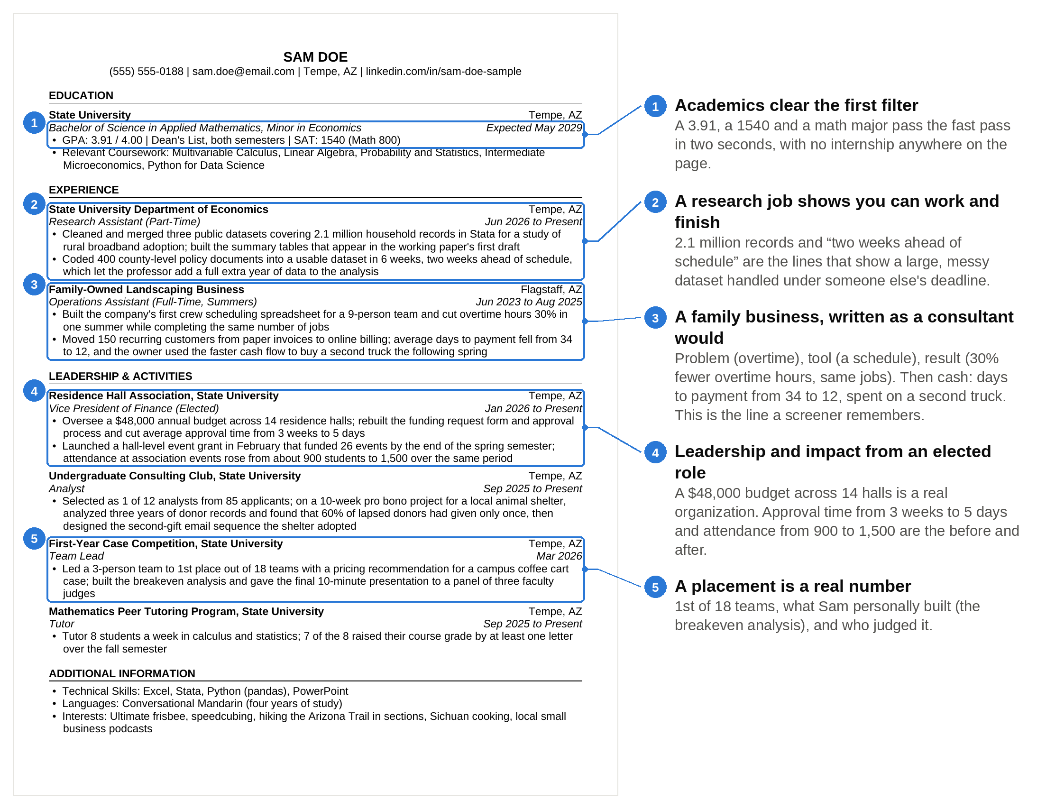
Not one bullet on Sam's page says consulting, and it still passes, because every box holds a number that moved.

A sophomore with no consulting internship passes the screen with numbers from campus leadership, a research job and a small business, because the screener is scoring evidence of impact, not the employer's name. Run the four scores again. Academics: a 3.91, a 1540 and a math major clear the first filter in two seconds. Leadership: an elected role with a $48,000 budget across 14 halls is a real organization with real stakes. Impact: approval time from 3 weeks to 5 days, attendance from 900 to 1,500, days to payment from 34 to 12. Distinctive: three summers running the back office of a landscaping company, ending with a second truck. A screener reads that last line and remembers it.

Three summers in a family business are the closest thing to consulting work a 19-year-old can show, if the bullets describe what changed. Sam didn't write "worked summers at family landscaping company." Sam wrote what a consultant would have done in that seat: found the operational problem (overtime), built the tool (a schedule), measured the result (30 percent fewer overtime hours, same jobs done). The second bullet is about cash, told in plain words: customers paid sooner, the business had more cash on hand, and the owner spent it on a truck. An interviewer who reads it will want to talk about it, which is the point.

The research job matters for a different reason. It's the only line on the page that shows Sam handling a large, messy dataset under someone else's deadline, which is most of what a first-year consultant does. "2.1 million household records" and "two weeks ahead of schedule" tell the screener Sam can work and can finish.

If your page looks like Sam's and you're worried it's thin, our roadmap for getting into consulting as an undergrad covers how to add one real experience before applications open, and our list of consulting internships for undergraduates covers where the sophomore-summer seats are.

Bullet rewrites: turning tasks into impact
The bullet formula is the same one the banking article teaches: verb, what, how, number. The consulting twist is in the number. On a banking page the number can be the size of the thing you touched ("a $600MM IPO"). On a consulting page the number has to be the result ("raised fill rates from 70% to 92%"). Three tests, in order:

- Could a stranger tell what changed because you were there?
- Could you defend the number for five minutes if an interviewer picked it?
- Is the number a result you produced, or just the size of the organization you were part of?

A consulting bullet is finished when its last clause is a number that changed because you were there. Here are the rewrites I make most often, with what moved in each one.

The club bullet
Don't write: "Responsible for organizing weekly meetings and recruiting events for the consulting club."
Write: "Grew the consulting club from 35 to 90 active members in one year by launching a six-week case training program; 11 members landed consulting internships, up from 3 the year before."

The first version lists what was on the calendar. The second has two outcomes (membership, offers), a mechanism (the training program), and a before-and-after on each number. "Responsible for" is the phrase that most reliably gets a bullet skipped, because it tells the reader what your job description said rather than what you did with it.

The research bullet
Don't write: "Assisted a professor with data analysis for an economics research project."
Write: "Cleaned and merged three public datasets covering 2.1 million household records in Stata; built the summary tables that appear in the working paper's first draft."

"Assisted" hides you. The rewrite names the tool, the scale of the data and where your work ended up. A screener now knows you've touched a real dataset and produced something a professor put in a paper.

The budget bullet
Don't write: "Managed a $50,000 annual budget for the student programming board."
Write: "Managed a $50,000 annual budget for the student programming board; cut per-event catering cost 18% by consolidating to one vendor, which funded 6 additional events over the year."

The first version has a number, and it's still weak, because $50,000 is the size of the thing you were handed. The rewrite keeps the input and adds the outcome: a cost you cut, how you cut it, and what the savings bought.

The summer job bullet
Don't write: "Worked at family restaurant during summers; handled scheduling, inventory and customer service."
Write: "Rebuilt the weekly inventory order for a 40-seat family restaurant using three months of sales data; food waste fell about 20% over the summer and the owner kept the new process after I left."

A list of duties becomes one problem, one fix, one result and one sign it stuck. If you worked a normal job, this is the bullet that separates you: not the job, but the evidence you looked for something to improve and improved it.

The internship bullet
Don't write: "Completed a market sizing analysis and presented findings to the team."
Write: "Sized the US market for a client's at-home diagnostic test at $1.4Bn with a bottom-up model from eligible patients, testing frequency and price; the estimate became the base case in the final steering committee presentation."

Same work, different page. The rewrite says what was sized, how, at what number, and what happened to the number afterward. That last clause is what a screener at a strategy firm looks for, because it tells them your work was used.

Where do the numbers come from if you didn't track them at the time? Reconstruct them. Membership lists, sign-up sheets, bank statements, the club's shared drive, the email you sent announcing the result. Ask the person you worked for; owners and advisors usually remember. Round the way you'd say it out loud ("about 20 percent," "from roughly 900 to 1,500"). Never put a number on a consulting resume that you can't explain how you got, because the interview is where that number gets tested.

How to show impact without a consulting internship
Most sophomores applying for Summer 2028 won't have a consulting internship, and the screen is built with that in mind. The firms know what a 19-year-old has had time to do, so the screen checks whether you moved a number inside the opportunities you had. Four places that evidence usually lives:

Campus leadership with numbers. A club, a student government role, a residence hall association, a team. The screener wants the size of the thing (members, budget, events), what you changed, and the before-and-after. An elected role counts for more than an appointed one, and a role you created counts for more than either. If your club has no numbers, start counting now: attendance, applicants, dollars raised, members retained. Six months of tracking turns "ran events" into "raised average attendance from 25 to 60."

A research job. Working for a professor shows you can handle a dataset, follow a methodology and hit someone else's deadline. Name the tool (Stata, R, Python), the scale (records, documents, surveys) and where the work landed (a working paper, a grant application, a dataset others now use). You don't need to be a co-author. You need to show the work was real and finished.

A nonprofit or a small business. These are the most underrated lines on a sophomore resume. A family business, a local nonprofit, a campus-adjacent startup: all of them have real problems and no one else to solve them. A sophomore with a spreadsheet can produce a result there that a 500-person company would never let an intern near. Write the bullet as a consultant would describe the project: problem, analysis, change, result.

A case competition. Placement out of how many teams, what the case asked, what you personally built (the model, the market sizing, the final presentation), and who judged it. A win against 18 teams is a real number. So is a second place against 32.

Then one more thing, and it comes from the Sternfels finding above. If you have a setback with a recovery in it, consider putting the recovery on the page. A club you inherited at 15 members and grew to 60 is a better line than one you joined at 60. A venture that didn't work, followed by what you built with what you learned, is a story interviewers ask about. The screener doesn't need the word "consulting" on your page; they need proof you can take a messy problem, organize people around it, and move a number.

Section-by-section rules for a consulting resume
The header. Name in capitals on the first line. Phone, email, city and state, and a LinkedIn URL on the second. Use an email with your name in it. No street address, no photo, no title, no personal website unless it's a portfolio someone asked for.

Education. School, city, degree, major and minor, expected graduation on one line. GPA on the next line, two decimals, out of 4.00. The GPA rules are the same ones the banking article uses: at 3.5 or above, list it. Between 3.3 and 3.5, list it and add your major GPA if it's higher. Below 3.3, leaving it off reads as "below 3.3" to every screener, so explain the trajectory instead ("GPA: 3.3 / 4.00; 3.7 over the last three semesters"). Test scores sit on the GPA line if you're listing them. A coursework line is worth including when your major isn't obviously quantitative and the courses are (econometrics, statistics, linear algebra); it's dead weight when it lists "Introduction to Business."

Experience. Paid or formal roles, most recent first. A part-time research job is Experience. A summer at a family business is Experience. A club is not, even if it took 20 hours a week; that goes under Leadership. Two to three bullets for the role that matters most to the reader, one or two for the rest. Past tense for finished roles, present tense for current ones. If you got a return offer, say so in parentheses after the title.

Leadership & Activities. The leadership section gets the space on a consulting resume that a banking resume would give to a fourth internship. Lead with your biggest role and give it three bullets. Use a "Previous Roles" note after your current title when you've moved up inside the same organization, because progression inside a club is its own signal. One bullet is enough for a competition or a team unless it carries a budget or a result.

Additional Information. Three lines. Technical skills you've actually used in a role on the page (Excel, PowerPoint, R, Python, SQL, Stata, Tableau); if you list it, expect to be asked about it. Languages with honest proficiency. Two to five interests specific enough to start a conversation. "Reading" and "sports" are not interests to a screener; "Sichuan cooking" and "crossword construction" are.

If you're applying to both banking and consulting, keep one master page and tilt it. The table shows what moves.

Element | Banking read | Consulting read
Top entry under Experience | The finance internship, led by deal size and exposure | The most analytical role, led by a result you produced
Leadership section | Two short entries near the bottom | Up to three entries, the biggest with three bullets
What the bullet number is | Often the size of the deal or the model | Always the outcome your work changed
Test scores | Common for sophomores, dropped by senior year | Common for sophomores and juniors; firms may ask for them in the form
Languages and international experience | A line if space allows | A line, kept, because staffing is global
Technical skills line | Finance tools: Capital IQ, Bloomberg, FactSet | Analysis tools: Excel, R, Python, SQL, Tableau

The same page passes both screens if you change what each bullet leads with, not what you did. Ana's rebuild took two hours because the raw material was already there; the banking version just led every bullet with the wrong half.

Where the cover letter fits
The cover letter is read after the resume, if it's read at all, and whether it's required depends on the firm and the office. BCG's US Associate page says cover letters "are not required" for summer or full-time applications, and that you can upload one under other documents [VERIFY: BCG's US Associate application page for the Summer 2028 cycle]. McKinsey and Bain have treated the letter as part of the application at many offices and as optional at others, and the requirement shifts by office and by cycle, so read the live posting for the offices you pick [VERIFY: McKinsey and Bain application requirements for the Summer 2028 cycle].

What the letter does that the resume can't: it answers "why consulting, why this firm, why you" in a voice, and it's the one place a named conversation with someone at the firm shows up in writing. What it can't do is rescue a resume that failed the first read, because the resume gets read first. The cover letter is read after the resume passes, so it can turn a maybe into an interview, but it can't fix a page that failed the first read. Our consulting cover letter guide has the four-paragraph structure and a full example. Write the cover letter after the resume is finished, never instead of finishing it.

One BCG detail worth knowing before you apply anywhere: BCG's careers FAQ says students can hold at most four open applications at once and should focus on two location preferences [VERIFY: BCG careers FAQ]. Pick your two offices once and keep them.

The mistakes that get consulting resumes cut
Most consulting resumes that get cut fail on something fixable in an hour, and the duties-instead-of-results bullet is the most common. These are the ones I see most, roughly in order of how often they cost someone an interview:

- Duties instead of results. "Responsible for," "assisted with," "helped," "participated in." Every one of these tells the reader what the role was supposed to involve, not what you did with it.
- Numbers that are inputs, not outcomes. "Managed a $40,000 budget" with nothing after it. The screener wants to know what you did with the $40,000.
- A banking page with the sections swapped. Deal-exposure bullets at the top, leadership squeezed to three lines, no outcomes. This is Ana's first draft, and I see it every cycle.
- Hiding the GPA. A missing GPA reads as below 3.3. If yours is low, show the trajectory or the major GPA, but show something.
- Two pages, or one page with 0.3 inch margins and 9 point font. Both say you couldn't prioritize.
- Claiming the team's result as yours. "Led" when you were one of five, "grew revenue 40%" for the company you interned at for eight weeks. Interviewers ask, and the conversation that follows is worse than a smaller honest number.
- A generic skills line. "Microsoft Office, communication, teamwork, leadership." Cut it. Skills show up in bullets or not at all.
- Design. Two columns, color, icons, a photo, a progress bar for "Excel proficiency." The Ladders study found cluttered, multi-column layouts performed worst with recruiters, and columns also come out scrambled when a system pulls the text from your PDF.
- Inconsistent formatting and typos. Two date formats on one page, a bullet without a period when the others have one, a firm's name misspelled, last cycle's year in the file name. A single typo gets a strong consulting resume cut, because attention to detail is the first thing a client notices on a slide.

Say this, don't say that: consulting resume lines
The lines below are the ones students most often get wrong, with the version that passes. All of them follow the same rule: a specific the reader can check beats a description the reader has to trust.

The GPA line
Don't write: "GPA: 3.4" (and nothing else), or leave it off because it's "not great."
Write: "GPA: 3.42 / 4.00 (Major GPA: 3.71) | SAT: 1510 (Math 780)"

The club leadership bullet
Don't write: "Served as president of the economics society and oversaw all club operations."
Write: "Lead a 55-member economics society; added a weekly data workshop that drew 30 students a session and tripled applications to the club's analyst program from 20 to 60."

The internship bullet
Don't write: "Gained exposure to strategy consulting through a summer internship at a boutique firm."
Write: "Built the pricing analysis for a regional retailer's loyalty program across 4,000 transactions; recommended a two-tier structure the client piloted in 12 stores in Q4."

The summer with no internship
Don't write: Nothing, and leave a gap for the summer after freshman year.
Write: "Camp Counselor and Head of Programming, Summer 2025: planned the daily schedule for 120 campers and 14 counselors; redesigned the rotation so no group waited more than 10 minutes between activities, down from 25."

The case competition line
Don't write: "Participated in a case competition and gained valuable teamwork experience."
Write: "Led a 3-person team to 1st place out of 18 teams; built the breakeven analysis and gave the final 10-minute presentation to a panel of three faculty judges."

The skills line
Don't write: "Skills: Microsoft Office, communication, leadership, problem solving, teamwork."
Write: "Technical Skills: Excel, PowerPoint, R, SQL, Tableau"

The interests line
Don't write: "Interests: Reading, travel, sports, music."
Write: "Interests: Trail running, crossword construction, Spanish-language film, pickup basketball, woodworking"

The research bullet
Don't write: "Research assistant for an economics professor."
Write: "Coded 400 county-level policy documents into a usable dataset in 6 weeks, two weeks ahead of schedule, which let the professor add a full extra year of data to the analysis."

What to do with this week
Open your current resume and read only the last clause of every bullet. If the clauses are nouns ("weekly meetings," "various analyses," "club operations"), you have a list of duties. If they're numbers with a before and an after, you have a consulting resume. Most pages I see are somewhere in between, with two or three bullets that work and eight that just list what was on the calendar.

Fix the eight. Go find the numbers: the membership list, the budget file, the email you sent when the thing you ran went well. Rank your entries by what the screen scores and cut from the bottom until you're on one page at 10.5 point. Then hand the page to someone who has worked in consulting, give them ten seconds, take it back, and ask what they remember. If the answer is your school, your GPA, your first job title and one line they can't stop thinking about, you've built the page Ana sent the night before her deadline. If the answer is "it looked fine," you're not done yet. If a consultant can't tell you what they remember after ten seconds with your page, the page isn't finished.

